# Mambu Exercises

Make sure that the necessary configuration sub-processes (***check the MPO training ppt***) are created, since these sub-processes will be used in all the exercises below.

## 1 - API call (POST)

Create an MPO process that performs an API call (POST) that creates a task for a given user in Mambu.

**Parameters**

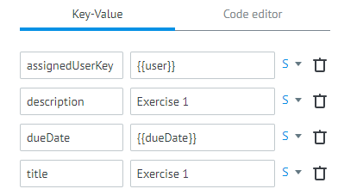

On the the “Task parameters” () menu add the inputs (*“user”* & *“dueDate”*) necessary to run the process

## 2 - API call (GET)

Create an MPO process that performs API call (GET) that obtains the information of a specific transaction performed.

**Parameters**

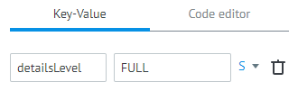

On the the “Task parameters” () menu add the input (*“transactionId”* – select an id from a transaction present in Mambu’s Sandbox) necessary to run the process

## 3 – Setup conditions

Using the MPO process created in exercise 2, create a condition blocker that will return the transaction details if it is higher than 100 and false if it is lower.

Add a Condition after the Process Call that defines the requested condition (amount >100 get details)

## 4 – Loop’s part 1

Using a similar MPO process to the one created in Exercise 2 replace the ***getById*** call by a ***getAll*** call and perform a loop that will apply the condition created in 3 to all the transactions present in the ***getAll*** call.

On the the “Task parameters” () menu add the input (*“depositAccountId”* – select an id from a deposit) necessary to run the process

## 5 - Loop’s part 2

On the process created in 4, in case the transaction value is higher than 100 create a user task using the process created in 3 – Use the call process component.

On the the “Task parameters” () menu add the input (*“depositAccountId”*, *“dueDate”* and *“userId”*,) necessary to run the process